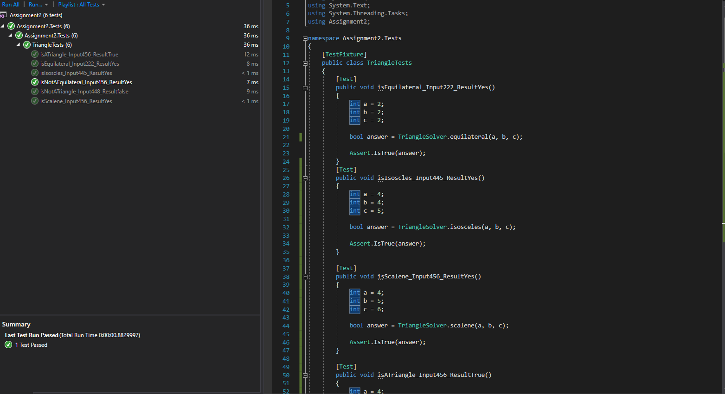

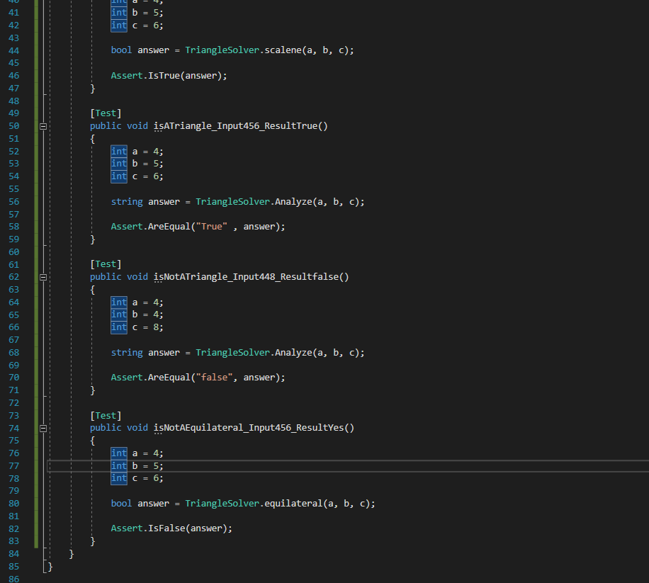

# Reason for these Tests: -

I have chosen 2 tests for equilateral triangle, 1 test for Isosceles, 1 test for Scalene and 2 tests for Analyze

Because I have made each method to check what kind of triangle it is

1. IsEquilateral(): -

This method checks if the user inputs a side of equilateral triangle or not.

If the test passes then the triangle is equilateral. Or else it is not an equilateral triangle

1. IsNotEquilateral(): -

This method checks if the user inputs a side of triangle is not an equilateral one.

If the test passes then the triangle is not an equilateral.

1. IsIsosceles(): -

This method checks if the user inputs a side of Isosceles triangle or not.

If the test passes then the triangle is Isosceles. Or else it is not an isosceles triangle

1. IsScalene() : -

This method checks if the user inputs a side of Scalene triangle or not.

If the test passes then the triangle is Scalene. Or else it is not an Scalene triangle

1. IsATriangle() : -

This method checks if the user inputs forms a triangle or not.

If the test passes then those sides will form a triangle. Or else it will not form a triangle

1. IsNotATriangle() : -

This method checks if the user inputs does not forms a triangle.

If the test passes then those sides will not form a triangle. Or else it will form a triangle